**Architecture of 8086**

[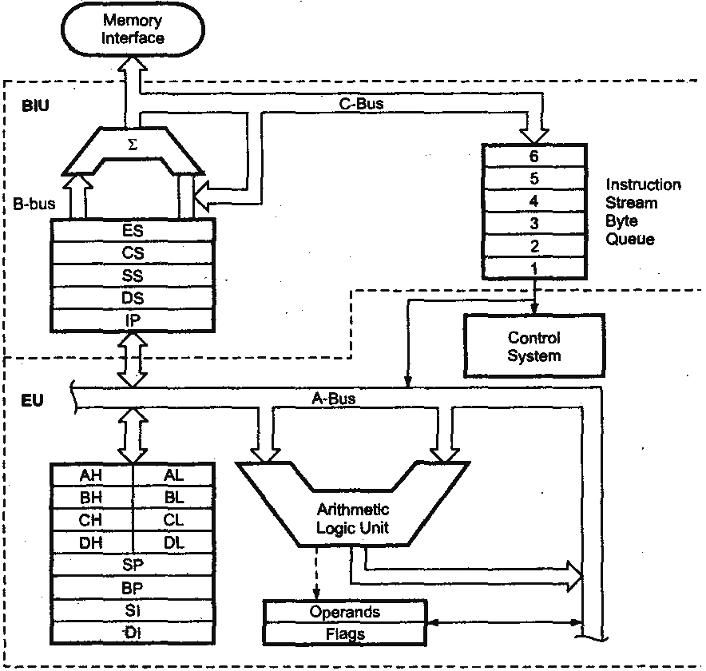](https://www.google.com.my/url?sa=i&rct=j&q=&esrc=s&source=images&cd=&cad=rja&uact=8&ved=0ahUKEwjNuYqLg73VAhXCy7wKHdFMBGoQjRwIBw&url=https://mediatoget.blogspot.com/2012/09/8086-architecture.html&psig=AFQjCNH0PxFiJiC7lE3iNRnKlx-Php8BMw&ust=1501917028489868)

**Status Register in 8086**

[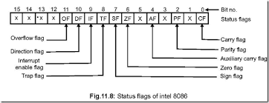](https://www.google.co.in/imgres?imgurl=http://lh3.ggpht.com/-w2OBz8e6SEA/VEu7rXlW3FI/AAAAAAAAqgw/OwbvgK5UIS8/The%208086%20Microprocessor%208-55-29%20PM_thumb_thumb.png?imgmax=800&imgrefurl=http://8051-microcontrollers.blogspot.com/2014/10/the-8086-microprocessor.html&docid=3w7CrtzAx6kHyM&tbnid=rgAPOgIYFve01M:&vet=10ahUKEwj06Ibc3rrVAhUKPI8KHckGBRAQMwgvKAYwBg..i&w=644&h=248&bih=674&biw=1024&q=8086%20flag%20register&ved=0ahUKEwj06Ibc3rrVAhUKPI8KHckGBRAQMwgvKAYwBg&iact=mrc&uact=8)

**Pin Diagram of 8086**

